**AI POWERED NUTRITION ANALYZER FOR FITNESS ENTHUSIASTS**

|  |  |
| --- | --- |
| Team ID | PNT2022TMID53820 |
| Team Members | Anitha R  Ashnat M  Abdul Raseeth Musavvir S A  Fahim Ahamed S |

**INTRODUCTION**

**A. Project Overview**

Food is essential for human life and has been the concern of many healthcare conventions. Nowadays new dietary assessment and nutrition analysis tools enable more opportunities to help people understand their daily eating habits,exploring nutrition patternsand maintain a healthy diet.Nutritional analysis is the process of determining the nutritional content of food. It is a vital part of analytical chemistry that provides information about the chemical composition, processing, quality control and contamination of food.

# B.Purpose

The main aim of the project is to building a model which is used for classifying the fruit depends on the differentcharacteristics like colour,shape, texture etc. Here the user can capture the images of different fruits and then the image will be sent the trained model. The model analyses the image and detect the nutritionbased on the fruits like (Sugar, Fibre, Protein, Calories, etc.).

**2.LITERATURE SURVEY**

**A.Existing problem**

Neutrino delivers nutrition-based data services and analytics to its usersand wants to turn into a leading source of the nutrition-related platform. The platform employs NLP and mathematical models from the optimization theory as well as predictive analysis to enable individualized data compilation.

The application relies on Artificial Intelligence to produce custom data related to smart calorie counterpowered by AI. Their artificial intelligence learns an individual’s tastes,preferences, and body type. All of this is packagedin a comprehensive nutrition and activity tracker.

# B. Problem Statement Definition

The main aim of the project is to building a model which is used for classifying the fruit depends on the differentcharacteristics like colour,shape, texture etc. Here the user can capture the images of different fruits and then the image will be sent the trained model. The model analyses the image and detect the nutrition based on the fruits like (Sugar, Fibre, Protein, Calories, etc.).

**3. IDEATION & PROPOSED SOLUTION**

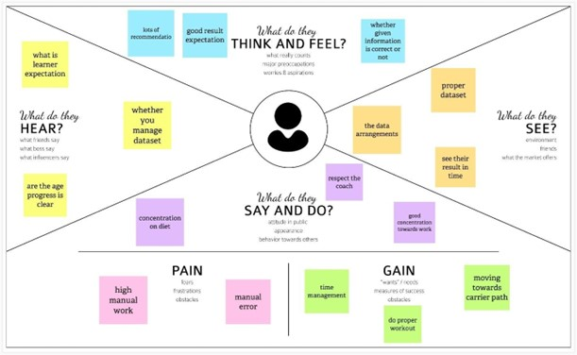

**B.PROPOSED SOLUTION**

|  |  |  |
| --- | --- | --- |
| **S.No.** | **Parameter** | **Description** |
| 1. | Problem Statement (Problem to be solved) | * The mainaim of the project is to builda model whichis used for identifying the fruit depends on the different characteristics like color, shape, texture etc using image processing. * Here the user can capture the images of different fruits and thenthe image will be analysed with the trainedmodel. * The model analyses the image and lists out the nutrients present in the fruitlike sugar, vitamins, minerals, protein etc. |
| 2. | Idea /Solution description | * The idea of this application is that the user can capture the images of different fruits and vegetables, and then the image willbe sent to the trained model. * The model analyses the image and detects the nutrition basedon the fruits like (Sugar, Fiber, Protein, Calorie intake, etc.). The above idea is achieved by using the Convolution Neural Network (CNN). * It is used to pick the raw pixelspresent in the image. FruitRecognition using Colorand Texture Features. |
| 3. | Novelty / Uniqueness | * The application has several uniquefeatures. The mainfeature is that the user need not have to visit or consult a Nutritionist (or) a Dietician to follow a fit and healthy diet. * This application has the feature of analysing the entire nutritional content of fruits and vegetables by simply scanning them. It provides for a personalized dietary requirement for individuals who havelimited preferences whilechoosing   food. |
| 4. | Social Impact / Customer Satisfaction | * This will acquire knowledge and provide information about nutrition. Now a days, no one follows the diet plan. Providing this information, they come to know about the nutrition present in each food item. * It is used to schedule a diet plan by taking the image of a food item and if we sendit, we canget information abouteach food |

|  |  |  |
| --- | --- | --- |
| 5. | Business Model (Revenue Model) | * Social mediais the bestway to spreadthe word aboutour application and with the help of influencers we can attract normal people. * Clustering andtargeting the fitness people with the help of local gyms.Allowing third-party vendors(Nutritional   Products) to sell theirproducts through our app via. |
| 6. | Scalability of the Solution | * Artificial intelligence (AI) can be used to predict investment outcomes quickly and effectively, as well as to devise strategies or establish long-term goals. Scalable AI pertains tohow data models, infrastructures, and algorithms can increase or decrease theircomplexity, speed, or size at scale in order to best handlethe requirements of the situation at hand. * As improvements continue with data storagecapacities as well as computing resources, AI models can be created with billions of parameters. Scalingup nutrition is a globalpush for action and investment to improve maternal, child nutrition and   various health problems. |

**C.ProblemSolutionfit**

The Problem-Solution Fit simply means that you have found a problem with your customer and that the solution you have realized for it actually solves the customer’s problem. It helps entrepreneurs, marketers and corporate innovators.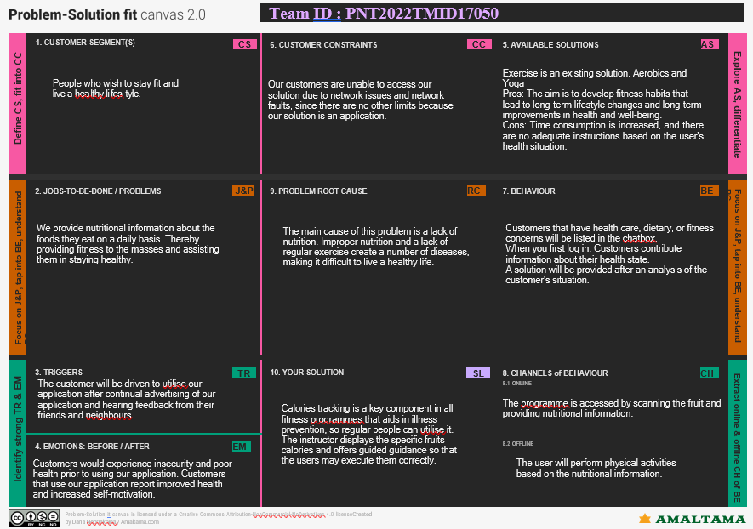

**4. REQUIREMENT ANALYSIS**

**A.Functional requirement**

* It will generate the diet plan as well as monitor the user’s health to classify the category of the disease and to create the diet plan. It will also reduce the cost of consulting the person nutritionist.
* The task of food detection/classification is not easy as it seems. All possible options related to the given Image.
* Image classification, object detection,segmentation, face recognition.
* Classification of crystal structure using a convolutional neural network.
* Nutrition is vital to the growth of the human body.
* Nutritional analysis guantees that the meal meets the appropriate vitamin and mineral requirements, and the examination of nutrition in food aids in understanding the fat proportion, carbohydrate dilution, proteins, fiber, sugar, and so on. Another thing to keep in mind is not to exceed our daily calorie requirements
* Computer-Assisted Nutritional Recognize Food Images – In order to solve this issue, a brand?new Convolutional Neural Network (CNN)- based food pictur created, as described in this study. We utilized our suggested strategy on two sets of actual food picture data.
* Here the user can capture the images of different fruits and then the image will be sent to the trained model. The model analyzes the image and detects the nutrition based on the fruits like (Sugar, Fiber, Protein, Calories, etc.)
* The Ultimate Workout at Home Solution This fitness AI software is designed with personalized training regimens for each individual. It began as “gym only software,” but has now improved its system to satisfy “at home fitness” expectations.
* You take a picture, dial in data such as whether you are eating breakfast or lunch and add a quick text label, and the app estimates the calorie content.
* This software collaborated with IBM’s natural language capability to provide 24-hour assistance and dietary recommendations.

**FOR EXAMPLE**

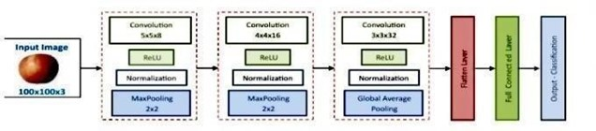

* The comparison of the proposed model with the conventional models shows that the results of this model are exceptionally good and promising to use in real-world applications.
* This sort of higher accuracy and precision will work to boost the machine’s general efficiency in fruit recognition more appropriately.
* A generic model for the dietary protein requirement (as with any nutrient) defines the requirement in terms of the needs of the organism,
* i.e. metabolic demands, and the dietary amount which willsatisfy those needs, i.e. efficiency of utilization, thus: dietary requirement = metabolic demand/efficiency of utilization.

**5. PROJECT DESIGN**

**A.Data Flow Diagrams**

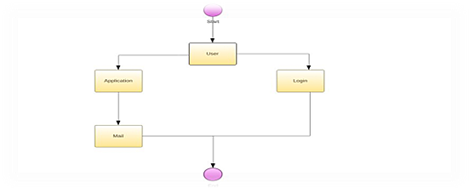

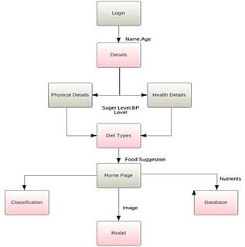

**5.1 Solution & Technical Architecture**

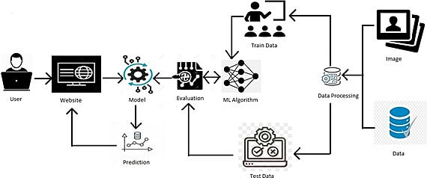

**Application Characteristics:**

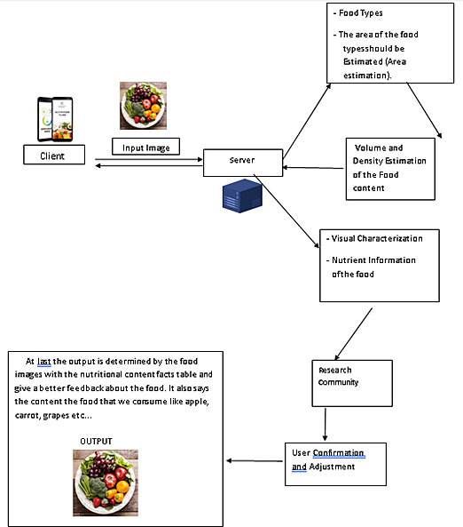

**6. CODING & SOLUTIONING** (Explain the features added in the project along with code)

**6.1 Feature 1**

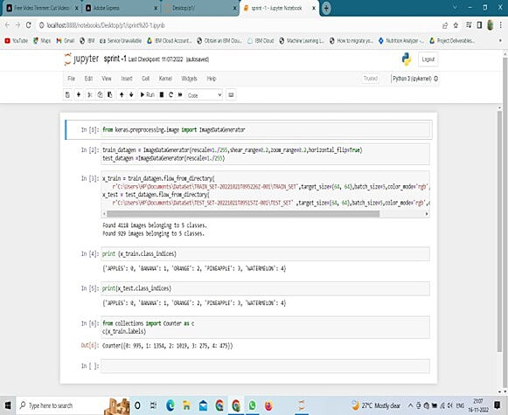

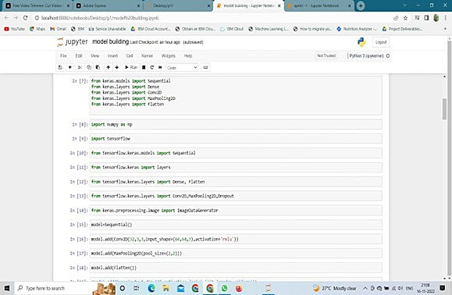

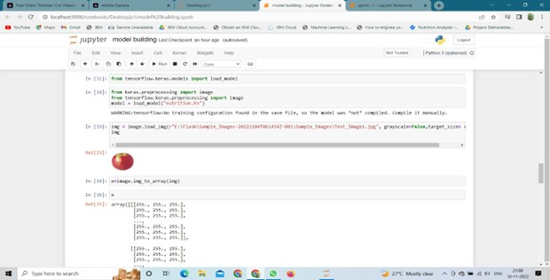

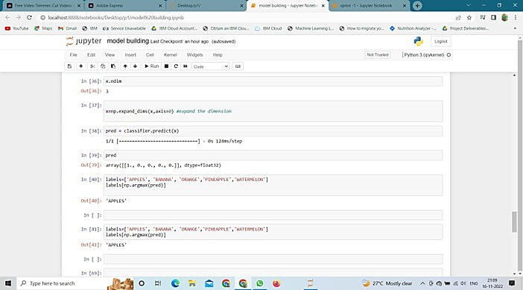

**6.1Feature 2**

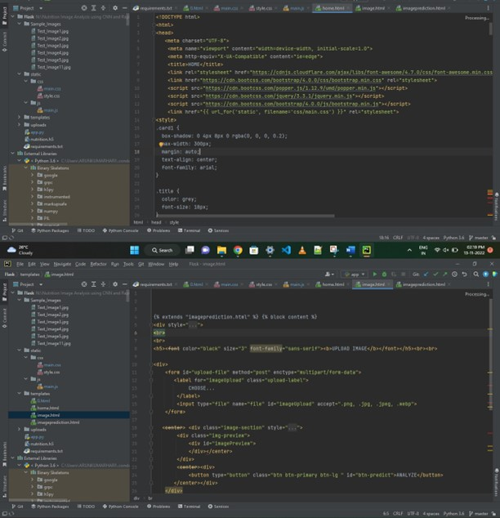

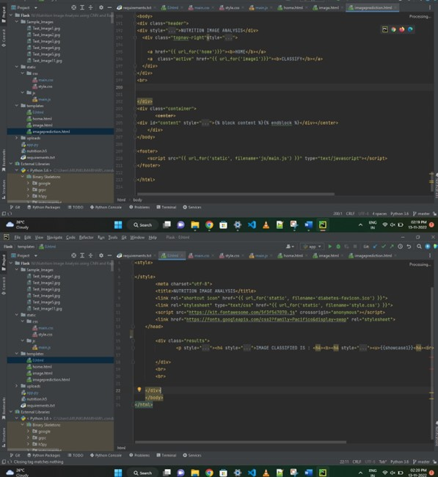

**7. TESTING**

**7.1 TestCases**

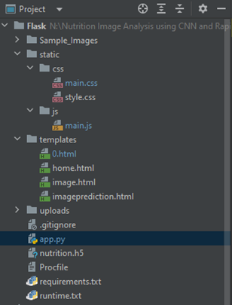

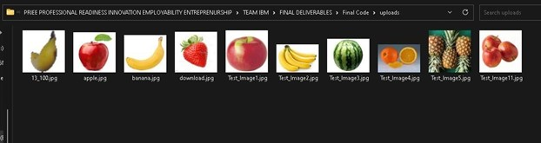

**7.2 User AcceptanceTesting**

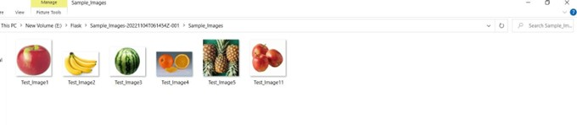

**8. RESULTS**

**Output:**

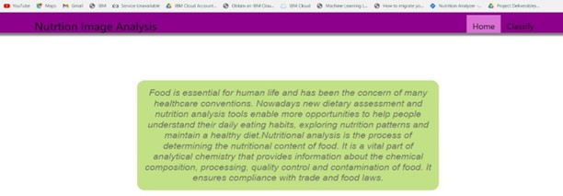

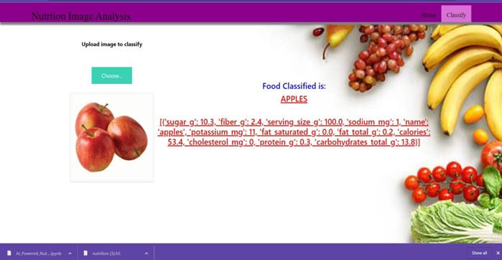

**9. CONCLUSION**

By the end of this project we will ,

* Know fundamental concepts and techniques of Convolutional Neural Network.
* Gain a broad understanding of image data.
* Know how to build a web application using the Flask framework.
* Know how to pre-process data.
* Know how to clean the data using different data preprocessing techniques.

**10. FUTURE SCOPE**

* AI is revolutionizing the health industry.
* It is majorly used in improving marketing and sales decisions, AI is now also being used to reshape individual habits.
* In future we don’t want to go to gym and do any diets. By using this nutrition fitness analyzer we can maintain our diet plans without any help from others and we can lead a happy and healthy life with good wealth.
* AI can easily track health behaviors and repetitive exercise patterns and use the data to guide you towards your fitness journey and diet plans.